1. Visit the URL.. <https://aws.amazon.com/console/>
2. Create your account on AWS

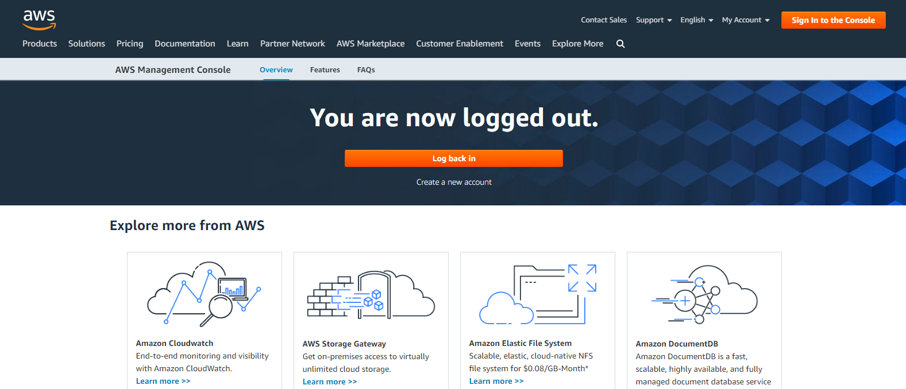

1. Provide details and payment details to create 12 months of Free Tier Access.

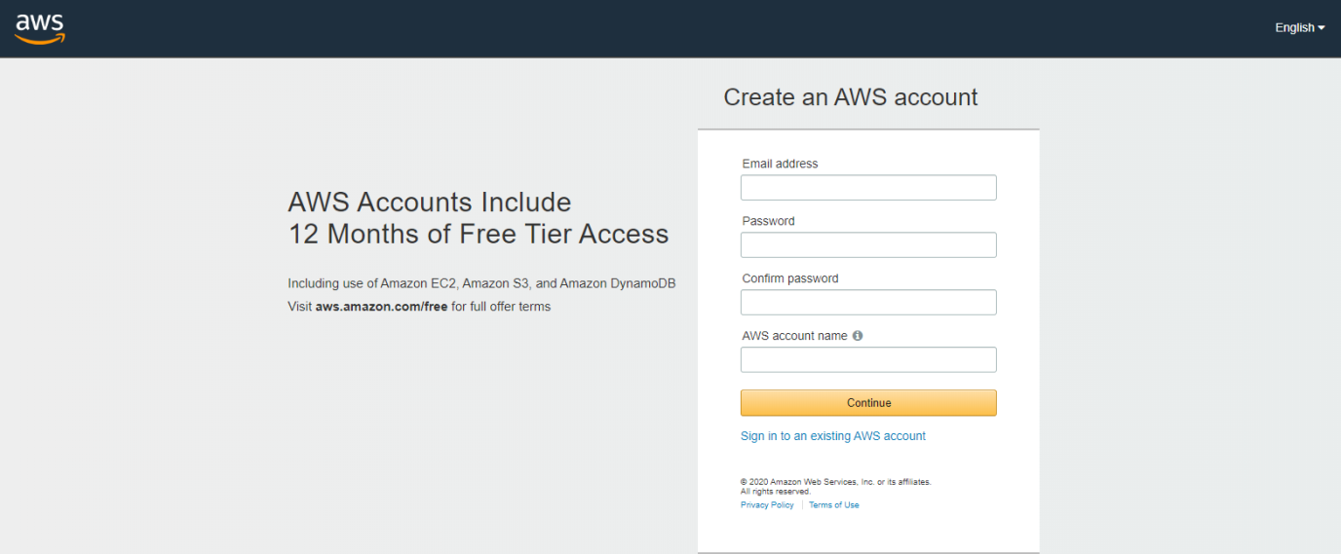

1. Sign IN to the AWS console and click on Services Link on the left hand top corner. 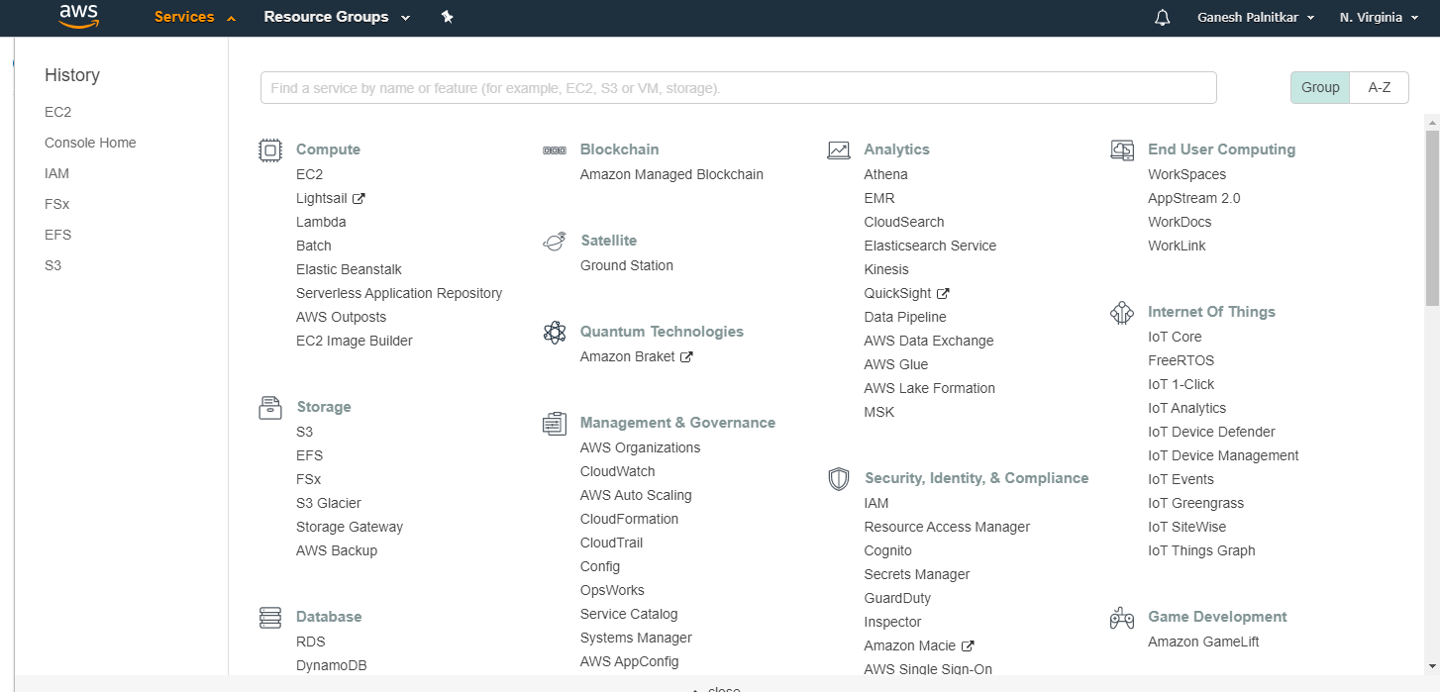
2. Here you will see all services that are available. Now click on the **EC2 service** under compute. Check which Region you are currently working on. The region information is available on the right hand top corner.

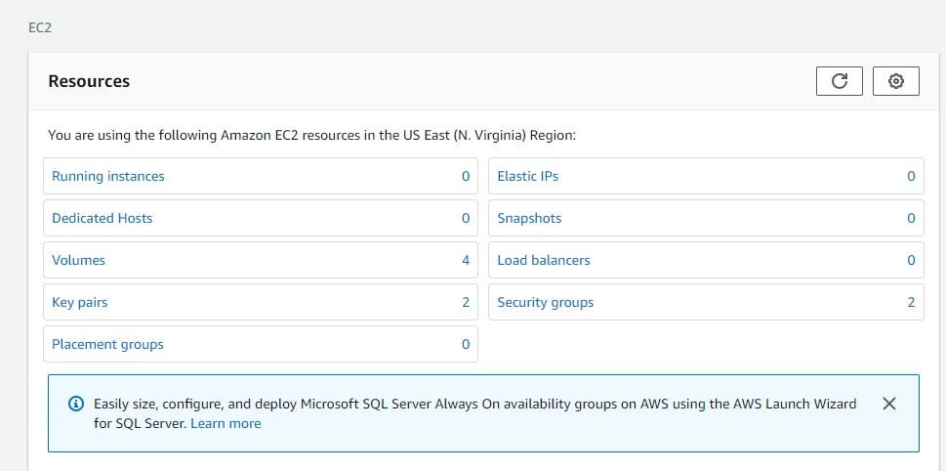

1. Click on **Running Instances**. and then click on **Launce Instance** to start VM creation process.

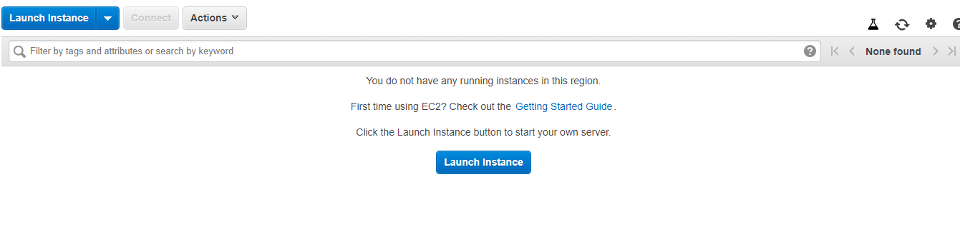

1. The VM creation process is a guided process starting with selecting a AMI ID (Amazon Machine Image ID).

Select the image that you feel fit for your requirement.

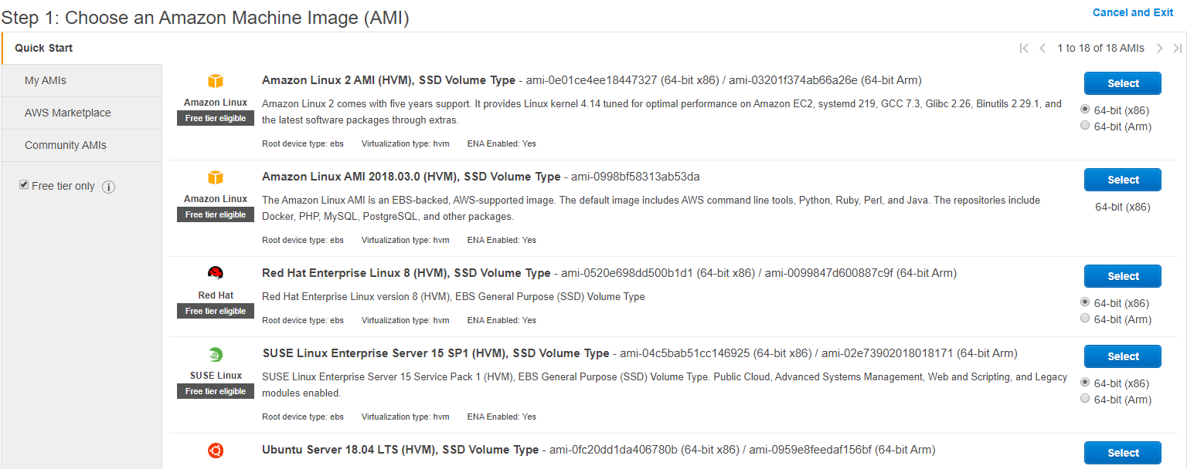

1. STEP-2: Choose the instance type

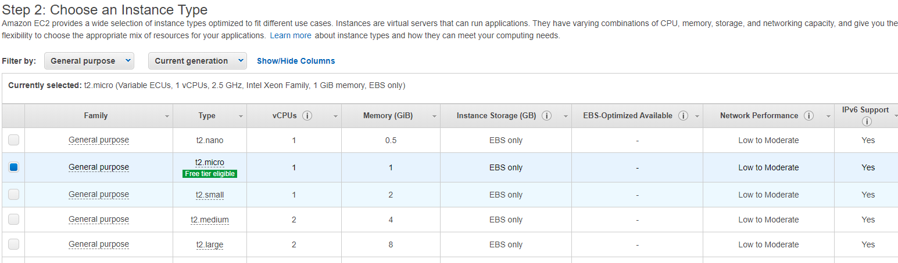

1. STEP:3 –Configure Instance details:

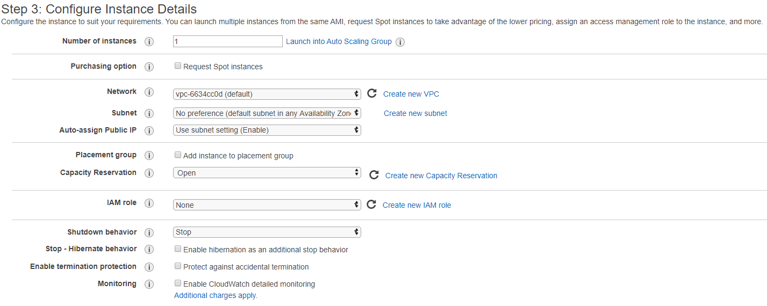

1. Select and Add storage.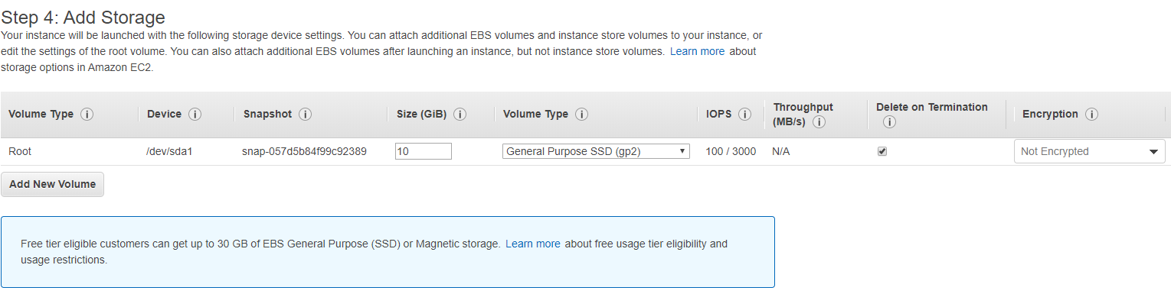
2. Add tags for quick reference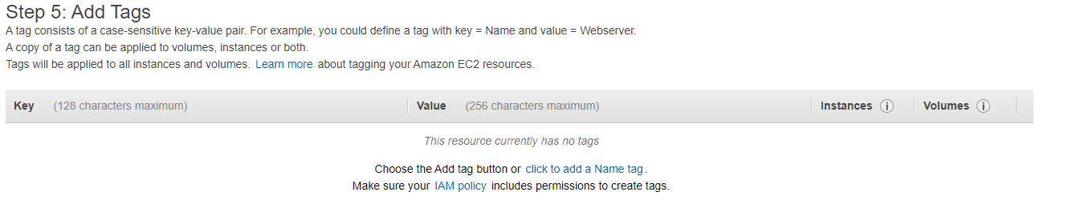
3. Configure Security group policy. If you have created a security group and have assigned policy, you can make use of that, or you will have to create a new sec group.

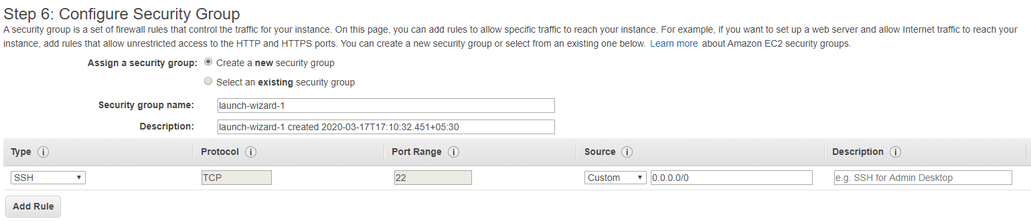

1. In step 6: you can review the entire configuration and then proceed by clicking on Launch button.
2. Once you proceed to launch the instance, you will be asked to provide a valid KeyPair name that will be added to the instance after creation. you can choose the option as existing key or create New key and proceed to launch the instance.

